Yoav Tadmor, Esq  Rachel C. Tadmor, Esq.  Email: Yoav@TadmorLaw.com | Tadmor & Tadmor llp  Commerce Building  340 Main Street, Suite 610  Worcester, MA 01608  telephone (508) 791-9400  Fax (508) 791-7914  e-mail: Yoav@TadmorLaw.com  www.TadmorLaw.com

Application for Alien Employment Certification Employee Worksheet

Please make sure that you complete each and every column completely and do not leave anything blank. The PERM application will not be able to be completed without all the information and this will cause delays in the filing of your PERM.

Please ensure this is typed (not handwritten) and emailed back in word version.

Part I. Alien Worker’s Information:

Sponsoring Employer: | RandStad Technologies
Company Address:

Has a previous employer ever filed a PERM on your behalf?: Yes

Has an I-140 ever been filed on your behalf?: yes

If so, was it approved? please provide copy of approval notice: Yes (document attached).

- Full Name as stated on the Passport:

First (Given): Shailendra
Middle:
Last (Surname) Name: Mishra

(a) Other name used (if any):
- Maiden Name (if applicable):

- Current Home Address (Street #, City, State/Province, Country and Postal Code): 34077 Paseo Padre Parkway Apt 109 Fremont, CA, 94555 US.

- Contact Information:
(a) Daytime phone #: 4085284354
- Home phone #: 5103246496
- E-mail address: mrshailendra@gmail.com

4. County of Citizenship: india

5. Country of Birth: india

6. Alien’s Date of Birth (mm/dd/Year):01/22/1981

7. Current Nonimmigrant Status/Class of Admission (e.g., H-1B, H-4, L-1A, L-1B, L-2, etc…): H1B

8. Alien Registration Number, if any:

- Alien Admission number (I-94):
05987327685

10. Please indicate all periods of stay in the U.S (i.e., exact entry date to and exit date from U.S.) in the last six years, include the visa classification (i.e., B-1, B-2, H-1b, H-4, L-1A, L-1B, L-2, etc...) for self, spouse (if applicable) and/or children (if applicable):

 | Visa Classification | Period of Stay in the U.S:  Entry to and Exit from U.S. (mm/dd/year)
(a) | L1B 07-18-2010 | 12-06-2012 (On Exit I was on H1B status)
(b) | H-1B 01-07-2013 | 06-15-2015
(C) | H1B 06-24-2013 | 01-29-2014
(d) | H1B 02-05-2014 | 03-21-2014
(f) | H1B 04-05-2014 | 05-22-2014
(g) | H1B 06-20-2014 | 07-16-2016
(h) H1B 08-18-2016

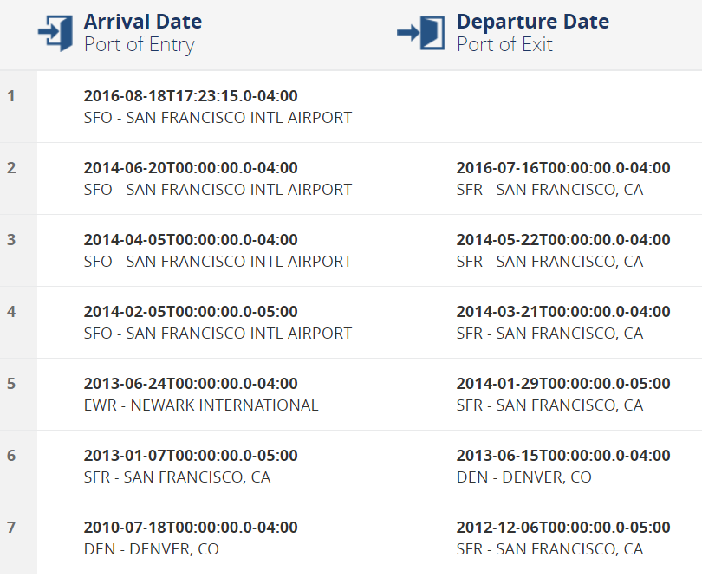

***If additional space is required, please attach the information on a separate piece of paper.
11. Any other Alien Employment Certification, a.k.a Labor Certification filed on your behalf? ____No ____Yes, if Yes, please provide the following:

Yes, Cisco system filed my Labor certificate.
(a) Date Filed:
(b) Name of the Employer:
(c) RIR or Regular Processing:
(d) State where it was filed: San jose ,CA
(e) Current Status of the Application: Approved

12. Has an I-140 been filed on your behalf? _____Yes _____No
If so, please provide copy of approval, denial, etc.

Yes, Its approved document attached.

13. Current Salary per year:
130K

Part II. Alien Worker’s Educational History (After High School (12th Grade)):

History # 1:
(a) Name of the University/Institute: | Pune University /Indira institute of Management
(b) Address of the Conferring University or Institute (Street #, City, State/Providence, Country and Postal Code): | Maharastra, Pune-bombay Highway road pune 33
(c) Field of Study | Master in computer science (MCA)
(d) From (month/ year) – To (month/year) | Apr/2003 to May/2006
- Degree Received  - Certificate/diploma issuance date | Nov-15-2006

History # 2:
(a) Name of the University/Institute: | BarKatullah Vishwavidyalaya, Bhopal, Jawahar Lal Nehru collage,
(b) Address of the Conferring University or Institute (Street #, City, State/Providence, Country and Postal Code): | Shyamla Hills,Bhopal Madhya Pradesh, India
(c) Field of Study | Bachelor of Computer Science
(d) From (month/ year) – To (month/year) | Mar-Apr 2000 to Mar-Apr-2003
- Degree Received  - Certificate/diploma issuance date | 2003

History # 3:
(a) Name of the University/Institute:
(b) Address of the Conferring University or Institute (Street #, City, State/Providence, Country and Postal Code):
(c) Field of Study
(d) From (month/ year) – To (month/year)
(e) Degree Received
(f) Certificate/diploma issuance date

History # 4:
(a) Name of the University/Institute:
(b) Address of the Conferring University or Institute (Street #, City, State/Providence, Country and Postal Code):
(c) Field of Study
(d) From (month/ year) – To (month/year)
(e) Degree Received

History # 5:
(a) Name of the University/Institute:
(b) Address of the Conferring University or Institute (Street #, City, State/Providence, Country and Postal Code):
(c) Field of Study
(d) From (month/ year) – To (month/year)
(e) Degree Received

Part III. Alien Worker’s Professional Experience:

List all jobs that you had held. Also list any other experience that qualifies you for the job opportunity for which the employer is seeking certification. Please note, if you have worked for the same employer or related entity or affiliate oversea and in the U.S., please list the respective employment separately.

Please note that we require both job duties AND the technical skills/languages/tools/databases, etc. that you have used in performing your jobs (present and past).

A. Job #1
1. Present/Current Employer Name: | Randstad Technologies
2. Complete Address (Street #, City, State/Providence, Country and Postal Code): | Randstad Technologies LP  340 Main Street STE 610 Worcester MA 01608
3. Type of Business: | Technology
4. Job Title: | Senior Software Developer
5. Start Date (mm/dd/Year) to End Date (mm/dd/Year): | Oct-18-2016 -present
6. Number of hours worked per week: | 40
7. Job Details (duties performed, use of tools, machines, equipment, skills, qualifications, certifications, licenses, etc… including phone number of the employer and the name of Alien’s supervisor).
  Job Details:
  Working on various security protocols like SAML, OAuth2.0 and WSO2 Server for authentication and Authorization,
  Technical skills/languages/tools/etc used on this job: OAuth 2.0, SAML, WSO2, AWS, Docker, Jenkins, Java,Scala, Object Analytics, Apache Oltu,
  Name of Supervisor: Ram Jamakandi
  Employer phone #: 7819391910

B. Job #2

1. Employer Name: | Cisco Systems Inc.
2. Complete Address (Street #, City, State/Providence, Country and Postal Code): | Unitited states , California, San jose
3. Type of Business: | Software
4. Job Title: | Software Engineering
5. Start Date (mm/dd/Year) to End Date (mm/dd/Year): | June-18-2012 to Oct-18-2016
6. Number of hours worked per week: | 40
7. Job Details (duties performed, use of tools, machines, equipment, skills, qualifications, certifications, licenses, etc… including phone number of the employer and the name of Alien’s supervisor).
  Job Details:  Technical skills/languages/tools/etc used on this job: RTP,RTSP, Object analytics algorithms, Video Motion detection Algorithms, java,J2EE technologies. | Woking on various Real time application which runs on TCP/IP protocols stack like RTP,RTSP,SNMP.  Working on Object analytics and motion detection on various video Cisco Cameras and incoders.  Completed Security NINJA White belt certificate offered by cisco.  Completed User authentication and Authorization security Certificate
  Name of Supervisor: | Sweeta Belenje
  Employer phone #:

C. Job #3

1. Employer Name: | SRS Consulting Inc.
2. Complete Address (Street #, City, State/Providence, Country and Postal Code): | 39465 Paseo Padre Pkwy, Suite 1100, Fremont,CA 94538
3. Type of Business: | Software
4. Job Title: | Programmer Analyst
5. Start Date (mm/dd/Year) to End Date (mm/dd/Year): | Oct-20-2011 to June-17-2012
6. Number of hours worked per week: | 40
7. Job Details (duties performed, use of tools, machines, equipment, skills, qualifications, certifications, licenses, etc… including phone number of the employer and the name of Alien’s supervisor).
  Job Details:  Technical skills/languages/tools/etc used on this job:RTP,RTSP, Object analytics algorithms, Video Motion detections algorithms, java,J2EE technologies | Developing and testing Cisco TCP/IP based RTP and RTSP Video cameras and cisco incoders.  Running analytics programs on RTP/RTSP video cameras.
  Name of Supervisor: | Venkatesh
  Employer phone #: | 5102520625

D. Job #4

1. Employer Name: | Tech Mahindra US
2. Complete Address (Street #, City, State/Providence, Country and Postal Code): | 2140 Lake Park BLvd,Suite 300,Richardson, Texas 75080
3. Type of Business: | Software
4. Job Title: | Software Eng.
5. Start Date (mm/dd/Year) to End Date (mm/dd/Year): | June-18-2010 to Oct-18-2011
6. Number of hours worked per week: | 40
7. Job Details (duties performed, use of tools, machines, equipment, skills, qualifications, certifications, licenses, etc… including phone number of the employer and the name of Alien’s supervisor).
  Job Details:  Technical skills/languages/tools/etc used on this job: | Developing and testing Cisco TCP/IP based RTP and RTSP Video cameras and cisco incoders.  Running analytics programs on RTP/RTSP video cameras.  RTP,RTSP, Object analytics algorithms, Video Motion detections algorithms, java,J2EE technologies
  Name of Supervisor: | Srinivas
  Employer phone #:

E. Job #5

1. Employer Name: | Tech Mahindra India
2. Complete Address (Street #, City, State/Providence, Country and Postal Code): | 9/7, Hosur Road, Opp. T Christ Collage, Bangalore-29
3. Type of Business: | Software
4. Job Title: | Software Eng.
5. Start Date (mm/dd/Year) to End Date (mm/dd/Year): | Augst-18-2008 to June-17-2010
6. Number of hours worked per week: | 40
7. Job Details (duties performed, use of tools, machines, equipment, skills, qualifications, certifications, licenses, etc… including phone number of the employer and the name of Alien’s supervisor).
  Job Details:  Technical skills/languages/tools/etc used on this job: | Developing and testing on various protocols like SNMP, WAP, TCP IP stack based applications.  Analysis of various video object analytics tools to run audio and video analytics data.  SNAP,TCLTK script, Java,J2ee, Oracle10g.  JavaSwings.  - Completed Audio andVideo analytics Training’s in Tech Mahindra.
  Name of Supervisor: | V. N Srinivas
  Employer phone #: | 918040243150

F. Job #6

1. Employer Name: | Subex Azure Ltd india
2. Complete Address (Street #, City, State/Providence, Country and Postal Code): | Adarsh Tech Park  Outer Ring Road,Devarabisannalli Bangalore- 560037 india
3. Type of Business: | Software
4. Job Title: | Software Engineer
5. Start Date (mm/dd/Year) to End Date (mm/dd/Year): | Feb-13-2007 to july-30-2008
6. Number of hours worked per week: | 40
7. Job Details (duties performed, use of tools, machines, equipment, skills, qualifications, certifications, licenses, etc… including phone number of the employer and the name of Alien’s supervisor).
  Job Details:  Technical skills/languages/tools/etc used on this job: | Wokoring on revenue management system, where need to find revenue leak in system using various reconciliation software techniques.  CDR Data collection on Switch, Java, XML, J2EE, Oracle 9i,
  Name of Supervisor:
  Employer phone #:

Please list any additional work experience you have, which qualifies you for the position on a separate sheet of paper.

